## Orange dataset

|  |  |
| --- | --- |
| Orange Telecom Prevention and Predicting Churn | <https://www.kaggle.com/code/visionary20/orange-telecom-prevention-and-predicting-churn> |

## **We can Predict using:**

**If we want to predict churn rate correctly, then Tree based classification using SMOTE would be recommended.**

**XGBoost Classifier Performs best and would be a recommended Model.**

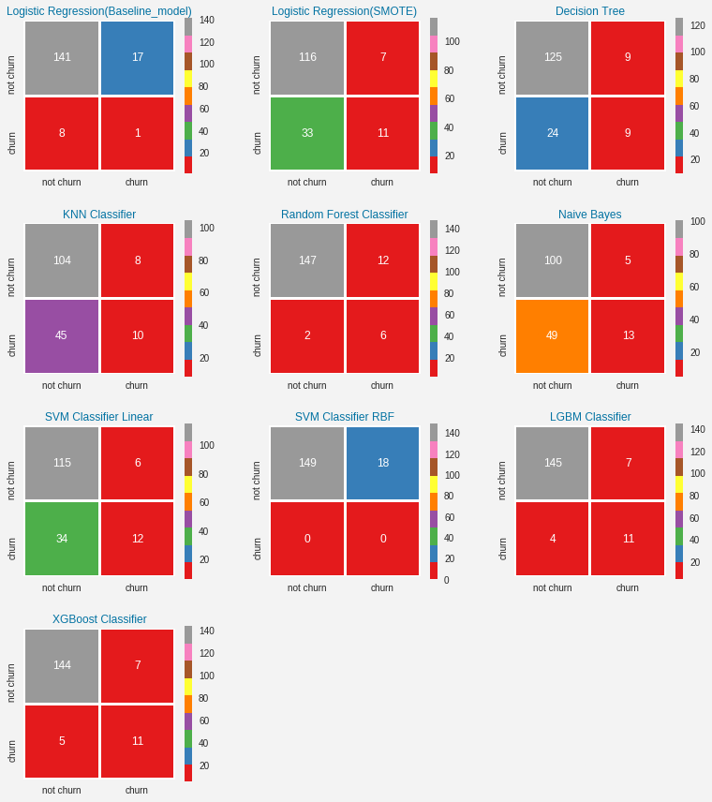

|  |  |  |  |  |  |
| --- | --- | --- | --- | --- | --- |
| Algorithms | Accuracy | Precision | Recall | F1 Score | MCC |
| Logistic regression (Baseline_model ) | 0.8503 | 0.8924 | 0.9463 | 0.9186 | 0.02 |
| Logistic Regression (SMOTE ) | 0.7605 | 0.9431 | 0.7785 | 0.8529 | 0.27 |
| Decision Tree | 0.8024 | 0.9328 | 0.8389 | 0.8834 | 0.26 |
| Random forest classifier | 0.9162 | 0.9245 | 0.9866 | 0.9545 | 0.46 |
| SVM classifier linear | 0.7605 | 0.9504 | 0.7718 | 0.8519 | 0.30 |
| XGBoost classifier | 0.9281 | 0.9536 | 0.9664 | 0.9600 | 0.60 |
| KNN | 0.68 | 0.92 | 0.69 | 0.79 | 0.16 |
| LightGBM | 0.93 | 0.95 | 0.97 | 0.96 | 0.63 |